|  |
| --- |
|  |
| The Specification |
| [Type the document subtitle] |
|  |
| **[Your Name]** |
| **[Pick the date]** |

[Type the abstract of the document here. The abstract is typically a short summary of the contents of the document. Type the abstract of the document here. The abstract is typically a short summary of the contents of the document.]

Table of Contents

[To update the table of contents, right click the message below and select Update Field (F9 on PC, ⌥⌘U on Mac).]

**No table of contents entries found.**

1. Pages
   1. Page Tree

Home  
Registration  
Main  
Game  
Scoreboard  
Profile  
FindLobbies  
GameSearching  
MainWithChat  
Lobbies

* 1. Home
     1. User Interface

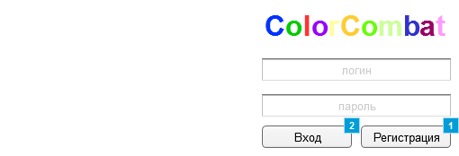

* + 1. Widget Table

|  |  |
| --- | --- |
| Footnote | Interactions |
| 1 | OnClick:  Case 1:  Open Registration in Current Window |
| 2 | OnClick:  Case 1:  Open Main in Current Window |

* 1. Registration
     1. User Interface

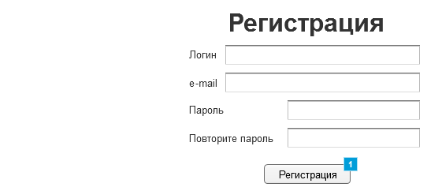

* + 1. Widget Table

|  |  |
| --- | --- |
| Footnote | Interactions |
| 1 | OnClick:  Case 1:  Open Home in Current Window |

* 1. Main
     1. User Interface

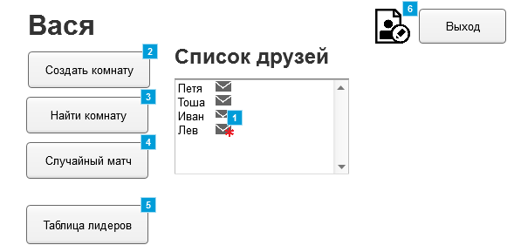

* + 1. Widget Table

|  |  |
| --- | --- |
| Footnote | Interactions |
| 1 | OnClick:  Case 1:  Open MainWithChat in Current Window |
| 2 | OnClick:  Case 1:  Open Lobbies in Current Window |
| 3 | OnClick:  Case 1:  Open FindLobbies in Current Window |
| 4 | OnClick:  Case 1:  Open Link in Current Window  Open GameSearching in Current Window |
| 5 | OnClick:  Case 1:  Open Link in Current Window  Open Scoreboard in Current Window |
| 6 | OnClick:  Case 1:  Open Profile in Current Window |

* 1. Game
     1. User Interface

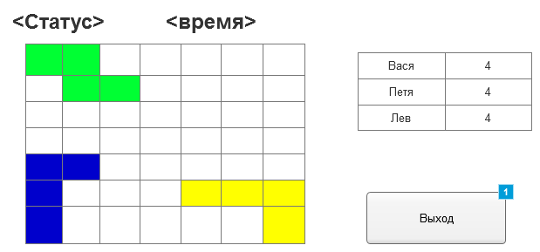

* + 1. Widget Table

|  |  |
| --- | --- |
| Footnote | Interactions |
| 1 | OnClick:  Case 1:  Open Main in Current Window |

* 1. Scoreboard
     1. User Interface

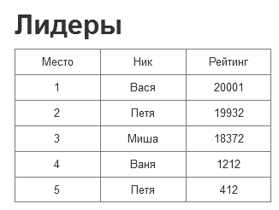

* 1. Profile
     1. User Interface

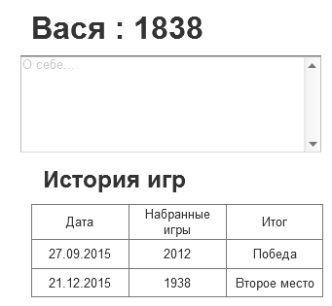

* 1. FindLobbies
     1. User Interface

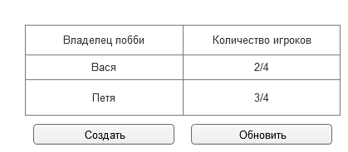

* 1. GameSearching
     1. User Interface



* 1. MainWithChat
     1. User Interface

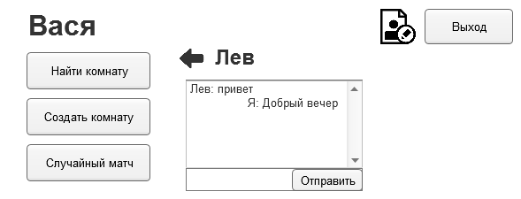

* 1. Lobbies
     1. User Interface

